#Description of the project
For this project, we want to implement an intuitive and insightful blockchain explorer for the Byzcoin which is the DEDIS blockchain. It has to provide an easy way for users to see and understand what's inside a blockchain by offering an intuitive and powerful user interface.
The actual problem of the blockchain is that it is a tool really complexe to be understood by a non-expert and it is in practice rare for users to actually verify the content of a blockchain and assert that a claimed state is true. It is also hard to see how the intrinseque mechanism of the blockchain works, ie. what is the content of each cryptographically linked block and how they participate in evolving the state of the blockchain. There is no visual tool to explain what a blockchain is and to visualize it clearly. Hence, the goal of this project is the implement an intuitive GUI for the blockchain to help understand how a blockchain is to non-expert and at the same time, to help to verify the blockchain for the developers.

#Plan and direction
This project will be split into two parts for two students: the first student will first create the GUI to explore the blockchain with the links, zooming on different blocks, and the second student will implement the exploration of the instances across the blocks.

For my part of the project, I will be doing the second part.

The plan of this project is first to try to adapt the code of the columbus_cli in order to display some blocks of the actual blockchain with their transactions and instances. Then it will be to recover all the instances of the same object across the blockchain. At the end, it will be to create a great GUI for this feature.
#what the project is
This project will be the implementation of the GUI for the blockchain using VueJS and 3D.js library for the visualization. This scheme is the idea for the visualization for the whole project.
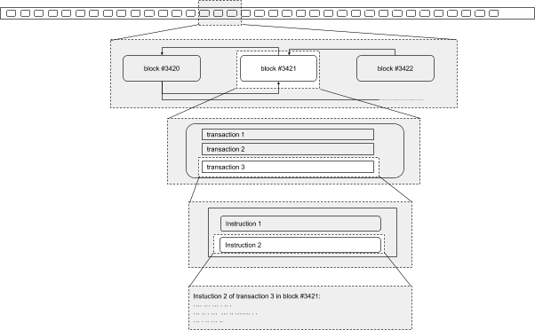
One thing that is needed is to help to find all the “state?” of one instance in all the blocks.
Hence, we could have a click on an instance which opens another square which display all the “state?” of the same instance.
#how I will do it

First will be to learn the visualization library, how to use it, how to be able to display what I want and at the same time, learn how to recover information from the blockchain.
Then it will be the implementation of the scheme using the 10 tips given on the drive about the interface.
The last thing will be to implement the followup of the instances which might take some time and reflexion on how to do it.
#info on topics: considered not to do or not chosen or not included

There might be some features that DEDIS needs for this visualization but since we are two students to have the same project, some feature might be done by the other student. This will be discuss with the assistant to avoid having the exact same projects. It seems like my project will be more on the followup of the instances.

